# CS 255 System Design Document Template

This template lays out all the different sections that you need to complete for Project Two. Each section has guidance to prompt your thinking. You will need to continually reference the interview transcript as you work to make sure that you are addressing your client’s needs. There is no required length for the final document. Instead the goal is to complete each section based on what your client’s needs are. Remove this note when you are finished, and replace all bracketed text with the relevant information.

## UML Diagrams

### UML Use Case Diagram

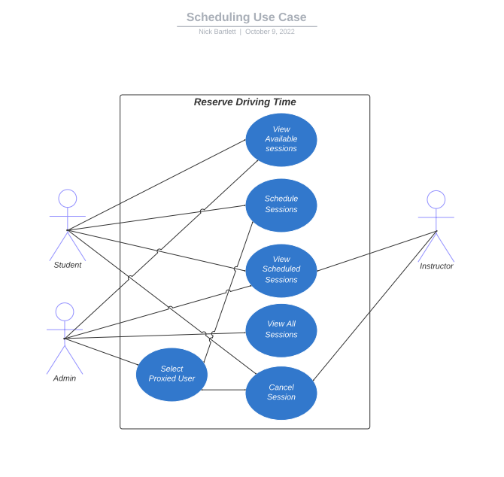

### UML Activity Diagrams

Login Activity Diagram

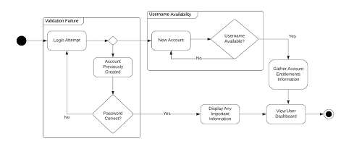

Reserve driving Activity Diagram

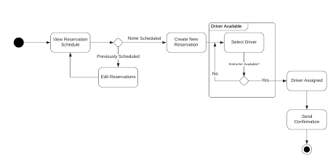

### UML Sequence Diagram

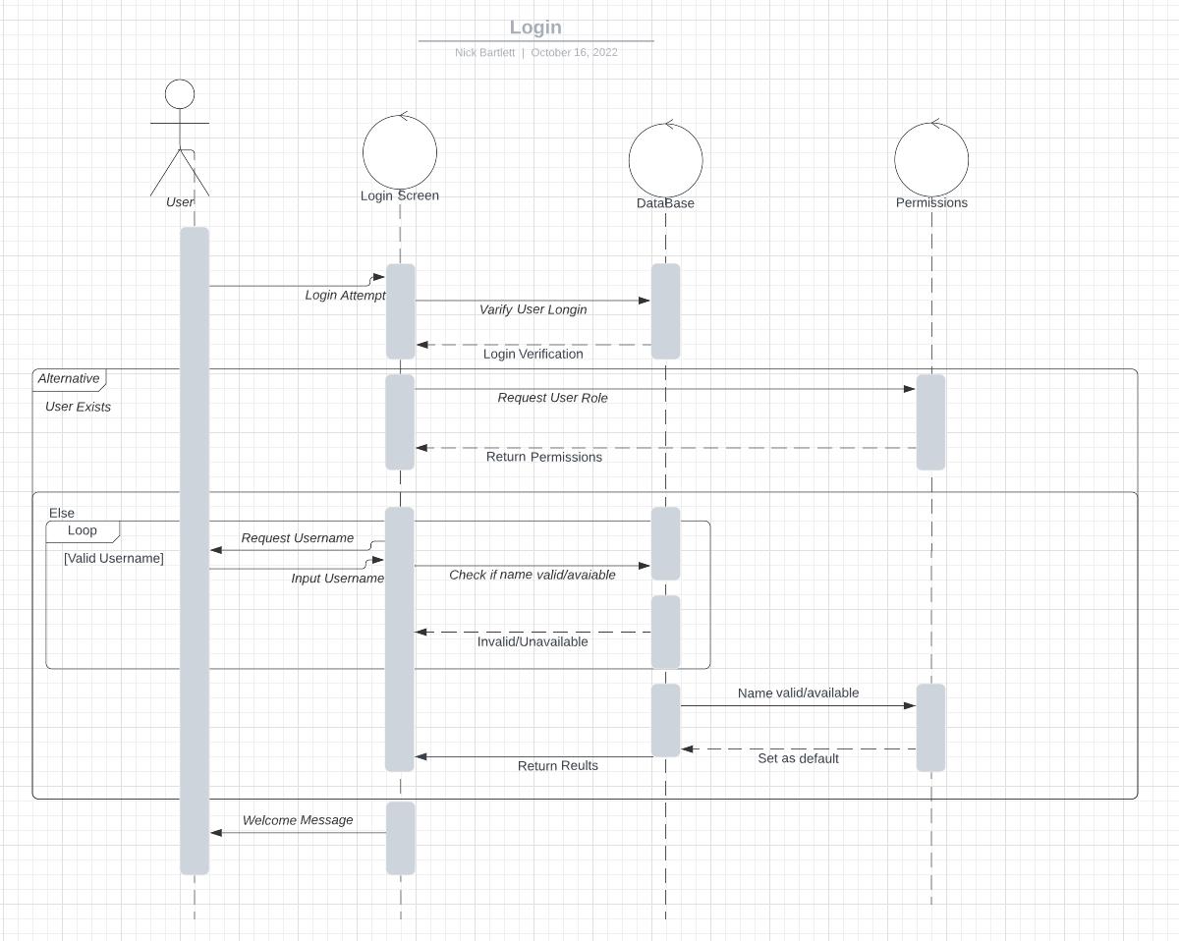

### UML Class Diagram

Abstract user class with derived student and instructor classes. A vehicle class. A reservation Class.

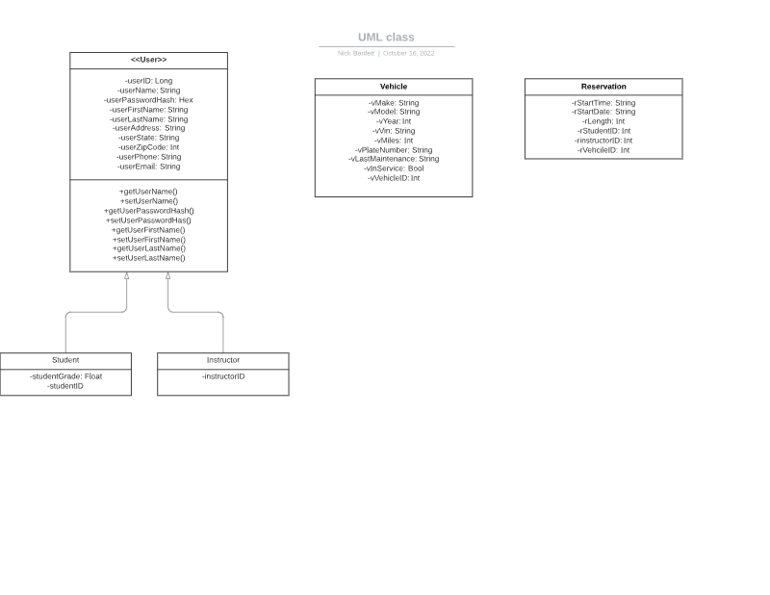

## Technical Requirements

The following is a list of technical requirements for web-based learning environment:

* Linux-Based web server, recommend AWS or Google hosting
* Web Pages to include class curriculum and tests compatible with Google Chrome
* Web Pages to include class curriculum and tests compatible with Apple iOS
* Web Pages to include class curriculum and tests compatible with Andriod OS
* APIs Designed using RESTful
* Login using RSA-encryption
* Web traffic encrypted with TSL 1.2 or higher